**Level 1:**

**1. Which statement about the state transition diagram and the table with test cases is correct?**

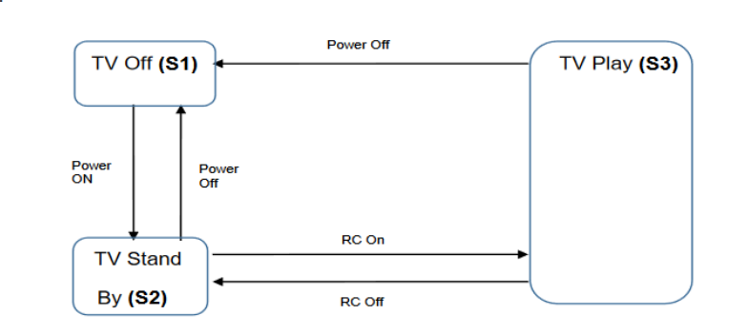

| **Test Case** | **1** | **2** | **3** | **4** | **5** |
| --- | --- | --- | --- | --- | --- |
| **Beginning state** | **S1** | **S2** | **S2** | **S3** | **S3** |
| **Power** | **Power On** | **Power Off** | **RC On** | **RC off** | **Power Of** |
| **Ending state** | **S2** | **S1** | **S3** | **S2** | **S1** |

**A. These test cases cover valid and invalid transitions in the chart.**

**B. These test cases show all possible valid transitions on the chart. - Correct Answer**

**C. These test cases cover some valid transitions on the chart.**

**D. These test cases cover pairs of transitions in the diagram.**

**2.Employees of the company are issued bonuses if they have worked for more than a year and have fulfilled the goals set in advance. These conditions can be presented in a decision table:**

| **Test** |  | **Т1** | **Т2** | **Т3** | **T4** |
| --- | --- | --- | --- | --- | --- |
| **Condition 1:** | **Over 1 year of experience?** | **Yes** | **No** | **No** | **Yes** |
| **Condition 2:** | **Is the goal set?** | **No** | **No** | **Yes** | **Yes** |
| **Condition 3:** | **Is the goal achieved?** | **No** | **No** | **Yes** | **Yes** |
| **Action** | **Issue a bonus** | **No** | **No** | **No** | **Yes** |

**Which scenario that is likely in real life is omitted in the table?**

**A. Condition 1 = YES, Condition 2 = NO, Condition 3 = YES, Action = NO**

**B. Condition 1 = YES, Condition 2 = YES, Condition 3 = NO, Action = YES**

**C. Condition 1 = NO, Condition 2 = NO, Condition 3 = YES, Action = NO**

**D. Condition 1 = NO, Condition 2 = YES, Condition 3 = NO, Action = NO - Correct Answer**

**Level 2:**

**3. Make a state and transition diagram for testing the following video game: After starting the game, you find yourself in the Castle of Mysteries, in a room with two corridors — to the right and to the left. If you go to the right, you will get to the dragon. The dragon gives you a riddle. If the answer is correct — you leave the castle and win. If not, the dragon gives another riddle. If you answer incorrectly for the second time, the dragon will eat you and you lose. If you go to the left, you will get to the witch. The witch gives a riddle. If the answer is correct, you leave the castle and win. If the answer is wrong, the witch takes you to the dragon.**

State and transition diagram for testing the video game described above:

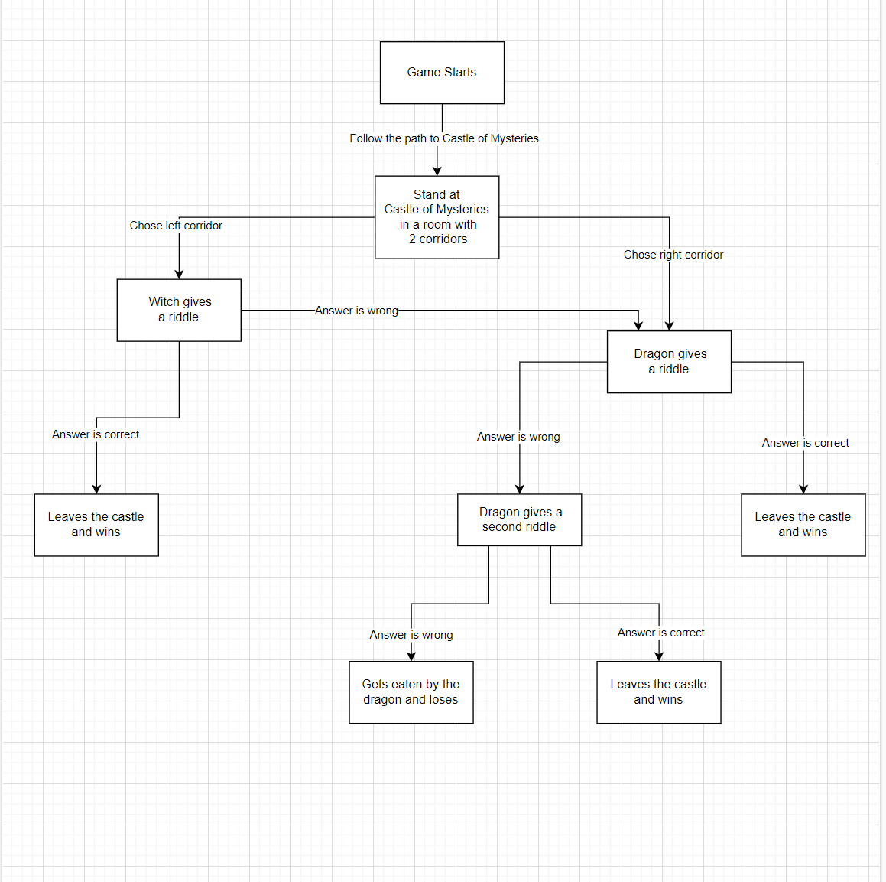

**4. How many test cases, according to the diagram, will be enough to test this game?**

**I believe we need 7 test cases to test the game, according to the diagram.** We need to test all possible scenarios.

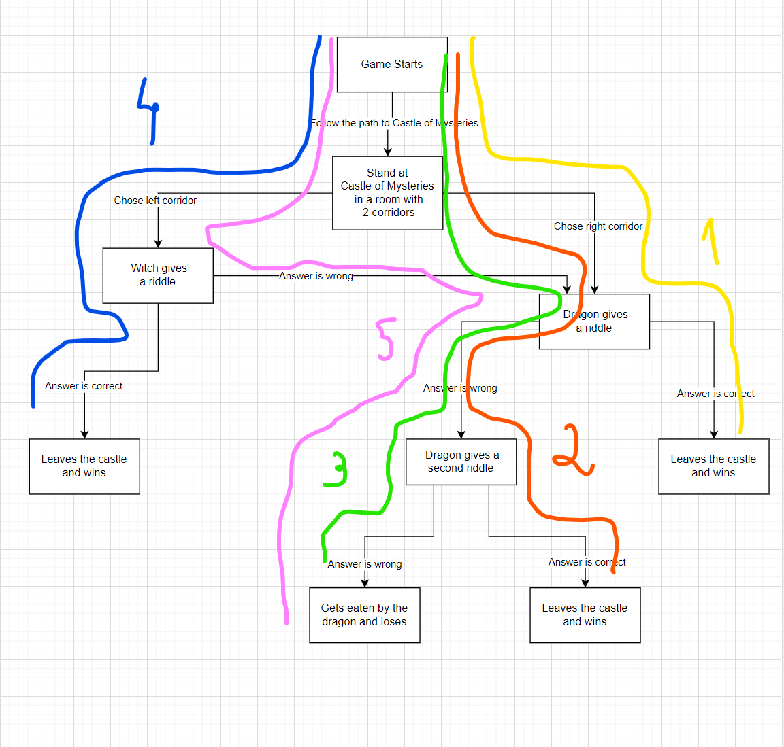

**Level 3:**

**5. We continue to develop a cat photo sharing app.**

**a. Write 5 use cases for how a typical user of your app would behave.**

| **Use Case ID** | 1.00 |
| --- | --- |
| **Use Case Description** | Comment a photo from another friend |
| **Actor** | User from CatSharing App |
| **Precondition** | User is logged in the CatSharing App and is able to see the main feed  User already has friends added in the CatSharing App |
| **Postcondition** | User is able to successfully comment a photo from another friend |
| **Basic Flow** | 1) User clicks on the search icon button in the top menu and writes the friend username in the search bar  2) The CatSharing App is able to successfully show the the friend profile to the user  3) User clicks a cat photo in his friend profile to expand  4) The CatSharing App is able to successfully expand the cat photo selected  5) User makes a comment in the description field below the cat photo  6) CatSharring is able to publish the comment, and it is added below the friend cat photo |
| **Extensions** | 5a) The comment that has more than the 90 character limit and CatSharing App displays an alert saying “Ups, your comment is too long!”  5b) User makes a comment that has less than the 50 character limit and CatSharing App displays an alert saying “Ups, your comment is too short!”  5c) User uses an emoji that is not a cat and CatSharing App displays an alert saying “Ups, you used a character that is not available” |

| **Use Case ID** | 2.00 |
| --- | --- |
| **Use Case Description** | Upload a cat photo |
| **Actor** | User from CatSharing App |
| **Precondition** | User is logged in the CatSharing App and is able to see the main feed  User has Cat photo available in the device |
| **Postcondition** | User is able to successfully upload a cat photo |
| **Basic Flow** | 1) User clicks on the “Upload” button in the bottom menu.  2) CatSharing App shows the frame that permits the user to select a cat photo from the device photo gallery.  3) User selects the photo he wants to publish and clicks on the “Publish” button at the bottom of the screen frame.  4) CatSharing shows a green pop-up with the message “Photo Uploaded” and photo is uploaded on the user profile feed |
| **Extensions** | 3.a) Photos is from animals other than cats, or people, or objects, and CatSharing App displays an alert saying “Sorry, you can only upload Cat photos”.  3.b) Photo size of less than 100 KB, and CatSharing App displays an alert saying “Ups, your image is too small. Upload at least an image with 100 KB or more”.  3.c.) Photo size of more than 300 KB, and CatSharing App displays an alert saying “Ups, your image is too big. Upload an image with 300 KB or less”. |

| **Use Case ID** | 3.00 |
| --- | --- |
| **Use Case Description** | Make a friend request |
| **Actor** | User from CatSharing App |
| **Precondition** | User is logged in the CatSharing App and is able to see the main feed |
| **Postcondition** | User is able to successfully make a friend request |
| **Basic Flow** | 1) User clicks on the search icon button in the top menu and writes the friend username in the search bar  2) The CatSharing App is able to successfully show the the friend profile to the user  3) User clicks on the “Add as Friend” button next to the username  CatSharing App is able to send friend request to the user and displays a message that says “Pending” in the same button |
| **Extensions** | - |

| **Use Case ID** | 4.00 |
| --- | --- |
| **Use Case Description** | Like a photo |
| **Actor** | User from CatSharing App |
| **Precondition** | User is logged in the CatSharing App and is able to see the main feed |
| **Postcondition** | User is able to successfully like a photo from another friend |
| **Basic Flow** | 1) User clicks on the search icon button in the top menu and writes the friend username in the search bar  2) The CatSharing App is able to successfully show the the friend profile to the user  3) User selects a cat photo in the friend profile and clicks on the white thumbs up icon below the cat photo  4) CatSharring is able to like the photo from the user friend and change the color from white to yellow from the thumbs up icon |
| **Extensions** | - |

| **Use Case ID** | 5.00 |
| --- | --- |
| **Use Case Description** | Sign-in CatSharing App |
| **Actor** | User from CatSharing App |
| **Precondition** | User already has CatSharing App installed in his phone  User already created a CatSharing account |
| **Postcondition** | User is able to successfully sign-in on CatSharing |
| **Basic Flow** | 1) User goes into his mobile phone and clicks on CatSharing App  2) CatSharing App opens and displays a frame with the email and password  3) User inserts the email and password for his personal account  4) CatSharing App opens the user main feed with cat photos from user friends |
| **Extensions** | 3a) CatSharing App doesn’t recognize username inserted and displays an error message that says “Wrong username” in a red pop-up  3b) CatSharing App doesn’t recognize password inserted and displays an error message that says “Wrong password” in a red pop-up |

**b. Draw a state transition diagram based on the written user scenarios and make a decision table for one of the options.**

Diagram based on Use Case ID 1.00:

